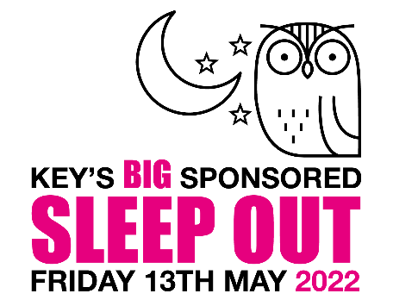
Registration Form
Thank you for your interest in our upcoming Sleep Out fundraising event, in support of Key Unlocking Futures Ltd. Please complete the details below to register you place/s and email to jaynea@keycharity.org.uk

Name | Age
Enter email
Email of lead organiser:
Registration fee:
£20 per person Lancashire Football Association
£10 per family (virtual sleep out)
Please pay via bank transfer to: Key Unlocking Futures Ltd, Account: 40910457, Sort: 20-55-34 Reference SLEEPOUT [Last name or company name] e.g. SLEEPOUTSmith or SLEEPOUTKey
Upon receipt of your registration fee, we will email you to confirm your place and provide you with a full information pack about the event and how to get started with your fundraising.
Please note that whilst Key has gone to great lengths to ensure safety at the physical event you are taking this challenge on at your own risk and must therefore be responsible for your own actions leading up to and during the event. The sleep out event at LFA is for over 18’s only.
If you are taking part in the ‘under the stars’ virtual event please ensure any children are adequately supervised.
O (please tick) I confirm, on behalf of all participants in my party, I have downloaded and read the sleep out terms and conditions and we agree to the conditions contained.

